**1. Launch EC2 Instances**

(a) EC2 Instance

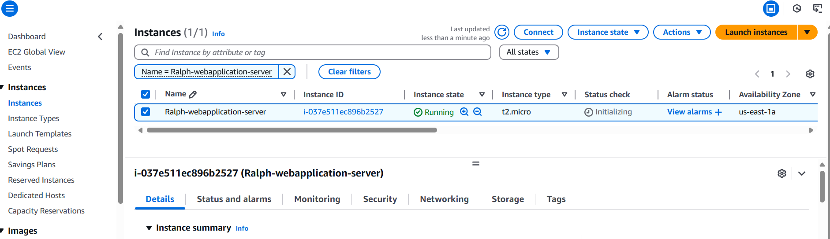

(2) Created Index.html and Style.css file. Files moved to html folder

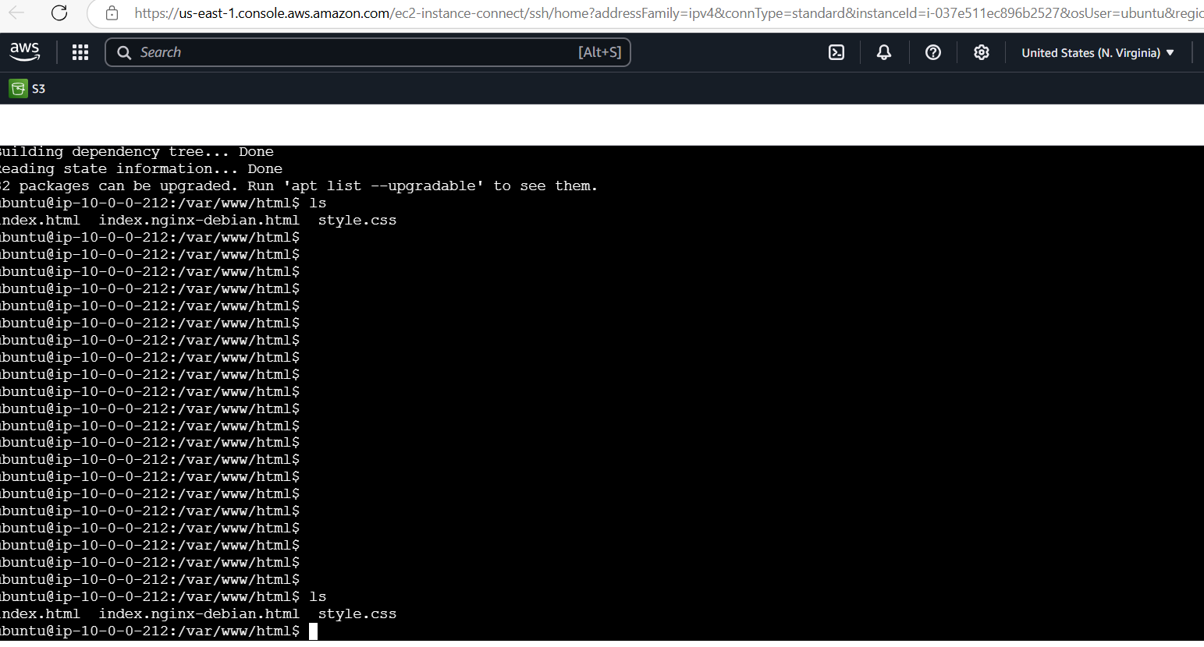

2(a) Simple web page with a welcome message and a clickable button

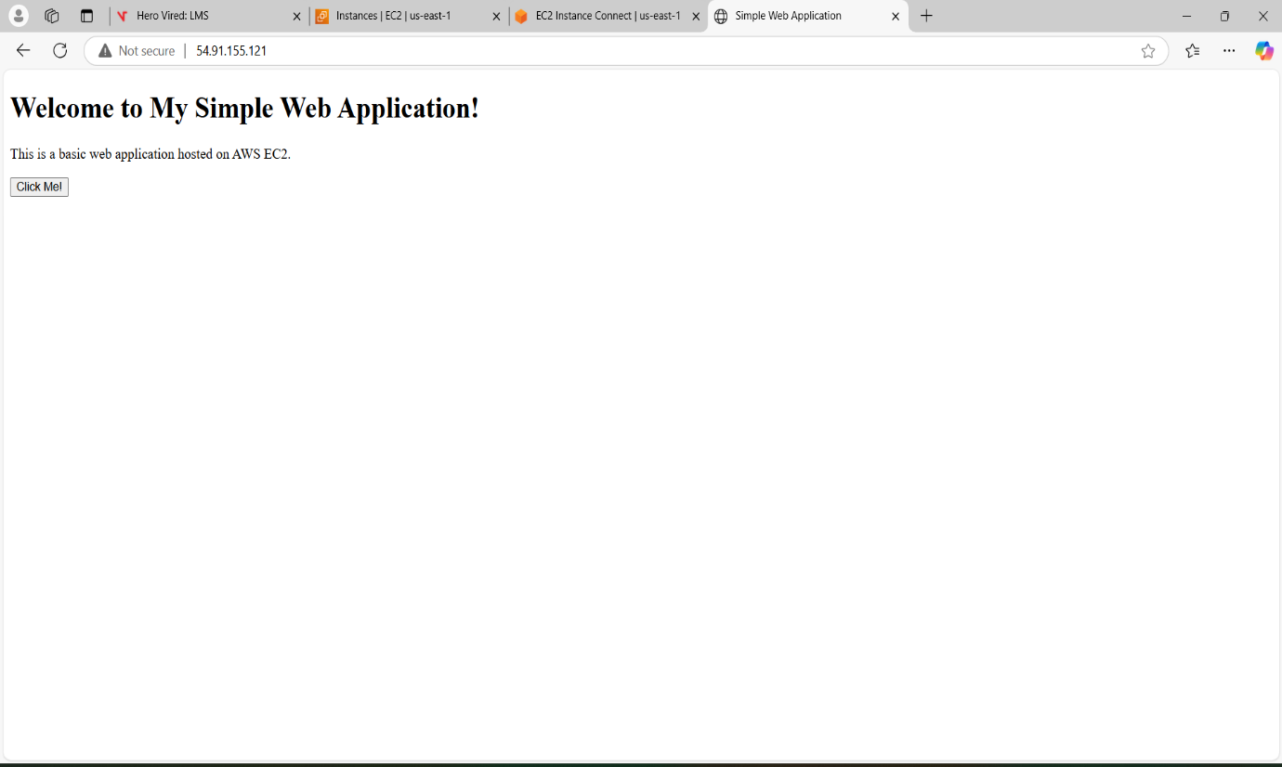

**3. Setting- Up Load Balancer (ALB)**

